**Chapter 5: Personality**

**Personality** is the pattern of enduring characteristics that produce consistency and individuality in a given person.

**five-factor model of personality**

* 1. **Extraversion**. People who score high in extraversion are characterized as outgoing, sociable, upbeat, friendly, assertive, and gregarious.
  2. **Neuroticism.** People who score high in neuroticism tend to be anxious, hostile, self-conscious, insecure, and vulnerable.
  3. **Openness to experience.** Openness is associated with curiosity, flexibility, vivid fantasy, imaginativeness, artistic sensitivity, and unconventional attitudes.
  4. **Agreeableness.** Those who score high in agreeableness tend to be sympathetic, trusting, cooperative, modest, and straightforward. People who score at the opposite end of this personality dimension are characterized as suspicious, antagonistic, and aggressive.
  5. 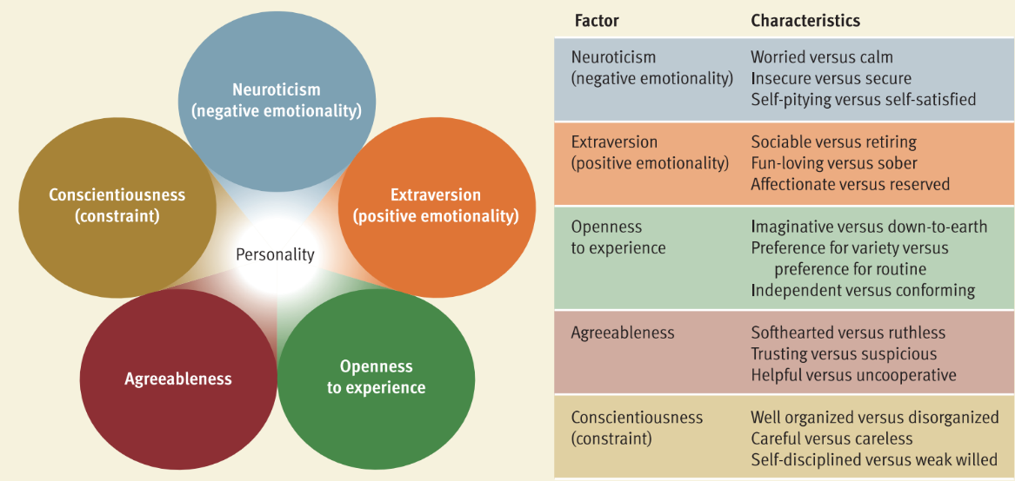**Conscientiousness.** Conscientious people tend to be disciplined, well organized, punctual, and dependable.

**Freuds iceberg theory (do conscious, un and preconscious)**

The **id** is the primitive, instinctive component of personality that operates according to the pleasure principle. which demands immediate gratification of its urges.

The **ego** is the decision-making component of personality that operates according to the reality principle. The ego is guided by the reality principle, which seeks to delay gratification of the id’s urges until appropriate outlets and situations can be found.

**Superego** is the moral component of personality that incorporates social standards about what represents right and wrong.

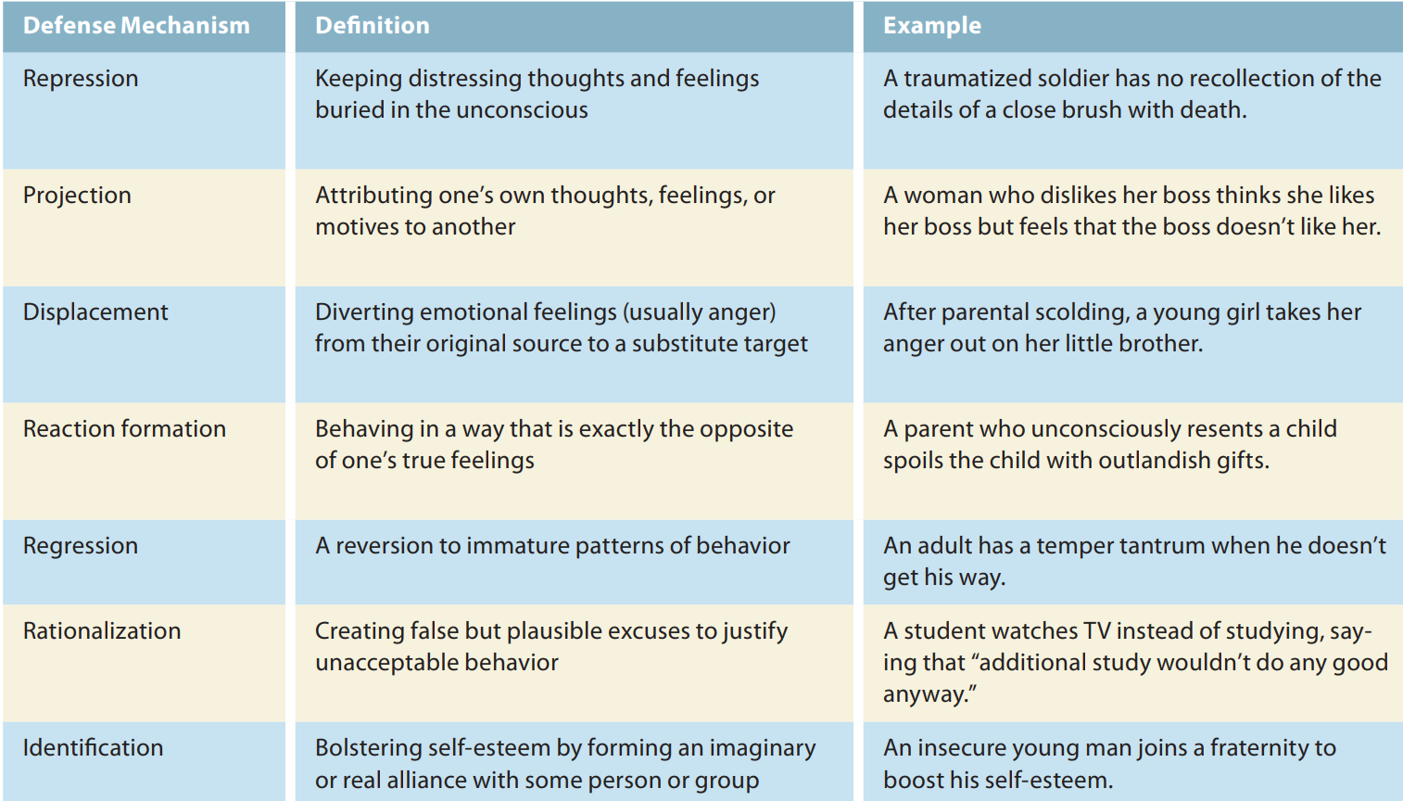

**Projection example: Dissatisfaction in Friendships**: If someone secretly feels resentful or envious of a friend’s success, they might start to believe that the friend is actually envious of them. This deflects attention from their own insecurities and reframes the problem as originating with the friend.

**Regression example:** When anxious about their self-worth, some adults respond with childish boasting and bragging (as opposed to subtle efforts to impress others). For example, a fi red executive having difficulty finding a new job might start making ridiculous statements about his incomparable talents and achievements

Freud's theory of **psychosexual stages** suggests that as children grow, they pass through a series of developmental stages where different parts of the body are the main focus of pleasure. How they manage challenges at each stage can leave lasting effects on their personality. If a child gets “stuck” at any stage, it can impact their behavior as an adult. This “stuckness” is called fixation and can happen if a child’s needs are either overindulged or neglected during a stage.

**1. Oral Stage (Birth to 1 Year)**

In the first year of life, a baby finds pleasure through activities involving the mouth, such as sucking, biting, and chewing. Feeding experiences, like weaning from breastfeeding or bottle-feeding, are very important at this stage. If a baby’s needs are not met well, they could become “fixated,” or stuck in this stage, and may develop habits like excessive eating, drinking, or smoking later in life.

**2. Anal Stage (1 to 3 Years)**

In this stage, the child’s pleasure centers on their bowel movements. Potty training becomes a key challenge, as it’s one of the first times they face rules about their body. How parents approach potty training can impact the child’s personality. For example, if parents are overly strict, the child might become very organized and perfectionistic (often called “anal-retentive”) or, on the other hand, messy and rebellious (known as “anal-expulsive”).

**3. Phallic Stage (3 to 6 Years)**

During this stage, children start to focus on their genitals and may develop feelings for the opposite-sex parent, known as the Oedipus complex. For boys, this means a strong attachment to their mother and jealousy toward their father; for girls, it’s the reverse. Children eventually need to let go of these feelings to bond with the same-sex parent. This identification with the same-sex parent helps children develop gender roles and conscience. Problems with this stage can lead to difficulties in forming relationships or authority issues later in life.

**4. Latency Stage (6 to Puberty)**

In the latency stage, children’s sexual interests become less intense. Instead, they focus on making friends, learning new skills, and building social relationships outside of their family. This stage is mostly about personal and social growth, with fewer challenges directly tied to sexual development.

**5. Genital Stage (Puberty to Adulthood)**

As teenagers reach puberty, they enter the genital stage, where sexual interests reawaken, but now the focus is on relationships with others rather than self-centered pleasure. Healthy development at this stage means they direct their sexual energy toward forming romantic relationships with others. If the earlier stages were resolved well, they are more likely to have healthy relationships and a well-rounded personality.

**JUNG’S ANALYTICAL PSYCHOLOGY**

Unlike Freud, who preferred a structured approach, Jung encouraged his followers to think independently

Both Jung and Freud believed that unconscious thoughts and feelings shape our personalities, but Jung’s ideas about the unconscious were different. He proposed that the unconscious mind has two parts:

1. **Personal Unconscious**: This is similar to Freud’s idea of the unconscious, containing memories and feelings that a person is unaware of because they have been repressed (pushed out of awareness) or forgotten.
2. **Collective Unconscious**: This is a deeper, shared level of the unconscious mind that Jung believed all humans inherit from their ancestors. The collective unconscious includes universal memories and experiences passed down through generations, connecting everyone across time and culture.

Within the collective unconscious, Jung said there are **archetypes**—universal, emotionally charged images and ideas that show up in dreams, art, literature, and religion. These archetypes are not memories of specific personal experiences but are symbols or ideas with deep, shared meanings for all humans. For example, one archetype is the **mandala**, or “magic circle,” which symbolizes unity and wholeness of the self. Jung found that many cultures use similar symbols, such as the mandala, even if they have never interacted, suggesting that these symbols come from the shared collective unconscious. Jung believed that understanding these symbols and archetypes helped him interpret his patients’ dreams, which he considered to be messages from the unconscious. Like Freud, he used dream analysis to understand his patients and uncover insights about their hidden thoughts and feelings.

**ALFRED ADLER INDIVIDUAL PSYCHOLOGY**

Unlike Freud, who focused on unconscious conflicts about sexuality, Adler believed the main human motivation was a desire to **strive for superiority**—to grow, improve, and overcome life’s challenges. Adler argued that early feelings of inferiority (especially as young children compare themselves to adults) motivate people to build new skills and abilities. He called this process **compensation**, which is a normal way of overcoming perceived or real weaknesses. However, when feelings of inferiority become too intense, they can lead to an **inferiority complex**—a constant feeling of weakness or inadequacy.

When a person has an inferiority complex, they might engage in **overcompensation**—focusing on status, power, or possessions (like flashy clothes or cars) to hide their feelings of inferiority from themselves and others. This self-deception makes people focus more on appearances than genuine self-improvement. WOAH NICE

Adler also believed that personality is shaped by social factors, like **birth order**. He proposed that the order in which a child is born influences personality, as each child experiences different dynamics in the family. For example, he suggested that only children might be spoiled, and first-borns might struggle when a new sibling arrives, leading them to become “problem children.” Although later research largely found little support for Adler’s birth order theory, the idea inspired further studies.

In recent years, Frank Sulloway has revisited birth order’s potential role in personality. Sulloway argued that birth order might shape traits like the **Big Five** personality traits, particularly through sibling competition for family roles. He suggested that first-borns might be more conscientious but less open and agreeable, tending to be more conventional and achievement-oriented, while later-borns might be more liberal and rebellious.

**B.F. Skinner's Behavioral Approach to Personality**

when responses are followed by favorable consequences (reinforcement), they are strengthened. For example, if your joking at a party pays off with favorable attention, your tendency to joke at parties will increase. Skinner believed that conditioning in humans operates much the same as it did in the rats and pigeons that he studied in his laboratory. Hence, he assumed that conditioning strengthens and weakens response tendencies “mechanically”—that is, without the person’s conscious participation.

**ALBERT BANDURA’S SOCIAL COGNITIVE THEORY**

Albert Bandura was one of the key theorists who modified traditional behaviorism by adding a cognitive element to it, especially in the 1960s. Unlike B.F. Skinner, who focused mainly on behavior shaped by the environment, **Bandura,** along with others like **Walter Mischel** and **Julian Rotter,** argued that human beings are not just reactive creatures molded by external forces. Instead, they are conscious, thoughtful, and emotional beings. These theorists initially called their approach **social learning theory**, but Bandura later renamed it social cognitive theory.

He emphasized that humans are self-organizing, proactive, and self-regulating, meaning they are active participants in shaping their behavior rather than passive recipients of external influences. According to Bandura, people set their own goals, plan for the future, and choose actions based on their predictions of outcomes. They seek to achieve desired results and avoid negative ones. Bandura’s theory is based on the concept of **reciprocal determinism**. This idea suggests that a person’s behavior, their personal beliefs and expectations (cognitive factors), and the environment all interact and influence each other. While the environment can influence behavior, people can also actively shape their environment. For example, a person can choose who they spend time with, which can alter their surroundings and, in turn, their behavior. They participate in shaping their surroundings, and this interaction can even give insights into their personalities based on how they influence and adapt to their physical environments.

Bandura's idea that people shape their environments suggests that rooms and houses can reflect the personalities of the people who live there. For instance, a **room** filled with unconventional decor, like abstract art or unique furniture, may signal that the occupant is creative or open to new experiences. Conversely, a space with formal decor and traditional furniture might reflect a more conventional, organized personality. (rooms has personality)

⭐ MEMORIZE NAMES = B. F. Skinner, Albert Bandura, and Walter Mischel. ⭐

**SELF EFFICACY:**

Self-efficacy refers to one’s belief about one’s ability to perform behaviors that should lead to expected outcomes.

**High Self-Efficacy**: If you believe you're good at talking to people, you might feel confident to join a new club or make new friends easily. This confidence can encourage you to take action.

**Less Procrastination**: People with high self-efficacy are more likely to complete tasks on time. **Better Health Outcomes**: Individuals who believe they can quit smoking are more successful in doing so. **Higher Academic Success**: Students with strong self-efficacy tend to achieve better grades. **Improved Mental Health**: High self-efficacy is associated with lower anxiety and depression levels.

**HUMANISTIC PERSPECTIVE**

**Backlash Against Other Theories**: Humanistic psychology arose as a reaction to:

* **Freudian Theory**: Criticized for focusing on primitive drives and unconscious conflicts.
* **Behaviorism**: Criticized for its mechanistic view and reliance on animal research, suggesting a fragmented understanding of human behavior.

They assume that (1) people can rise above their primitive animal heritage and control their biological urges, and (2) people are largely conscious and rational beings who are not dominated by unconscious, irrational needs and conflicts. (important memorize these two points)

**person-centered theory**

self-concept comprises beliefs about one's nature, unique qualities, and typical behavior, effectively serving as a mental image of oneself. For instance, an individual’s self-concept may include beliefs like “I’m easygoing,” “I’m crafty,” or “I’m hardworking.” Rogers posited that people are generally aware of their self-concept, which is not hidden in the unconscious. However, he acknowledged its subjective nature, noting that individuals often distort their experiences to maintain a favorable self-concept. For example, someone may believe they are intelligent despite receiving poor grades, leading to a state Rogers termed **incongruence**, the disparity between one’s self-concept and actual experiences. In contrast, a self-concept that accurately reflects reality is considered **congruent.**

In terms of personality development, Rogers believed childhood experiences play a crucial role in shaping congruence or incongruence. He argued that individuals have a fundamental need for affection, love, and acceptance from others, particularly from parents during early life. Some parents provide conditional love, meaning their affection depends on the child’s behavior and adherence to expectations. When children perceive parental love as conditional, they may block out experiences that make them feel unworthy of love, leading to a distorted self-concept. Conversely, unconditional love fosters a sense of worthiness, allowing children to accept their experiences more fully without distorting them. Rogers theorized that individuals who grow up with a conditional view of affection tend to distort their experiences to seek acceptance from others. He also highlighted that experiences threatening one’s self-perception are primary sources of anxiety. Individuals with highly incongruent self-concepts are more susceptible to anxiety because their perceptions often clash with reality. To cope with this anxiety, people might engage in defensive behaviors, such as ignoring or denying experiences that threaten their self-concept. For example, a woman who views herself as “nice” but exhibits selfish behavior might disregard moments of selfishness or rationalize negative feedback from others as jealousy or disappointment.

**Maslow's Theory of Self-Actualization and hierarchy of needs**

He famously stated that while Freud focused on the "sick half" of psychology, it was essential to explore the "healthy half.". Maslow proposed that human motivations are organized into a **hierarchy of needs**, often illustrated as a pyramid. The pyramid consists of levels, with basic needs at the bottom, such as physiological and security needs. These must be satisfied before higher-level needs can be addressed. The highest need is **self-actualization**, which is the drive to realize one’s potential and become the best version of oneself.

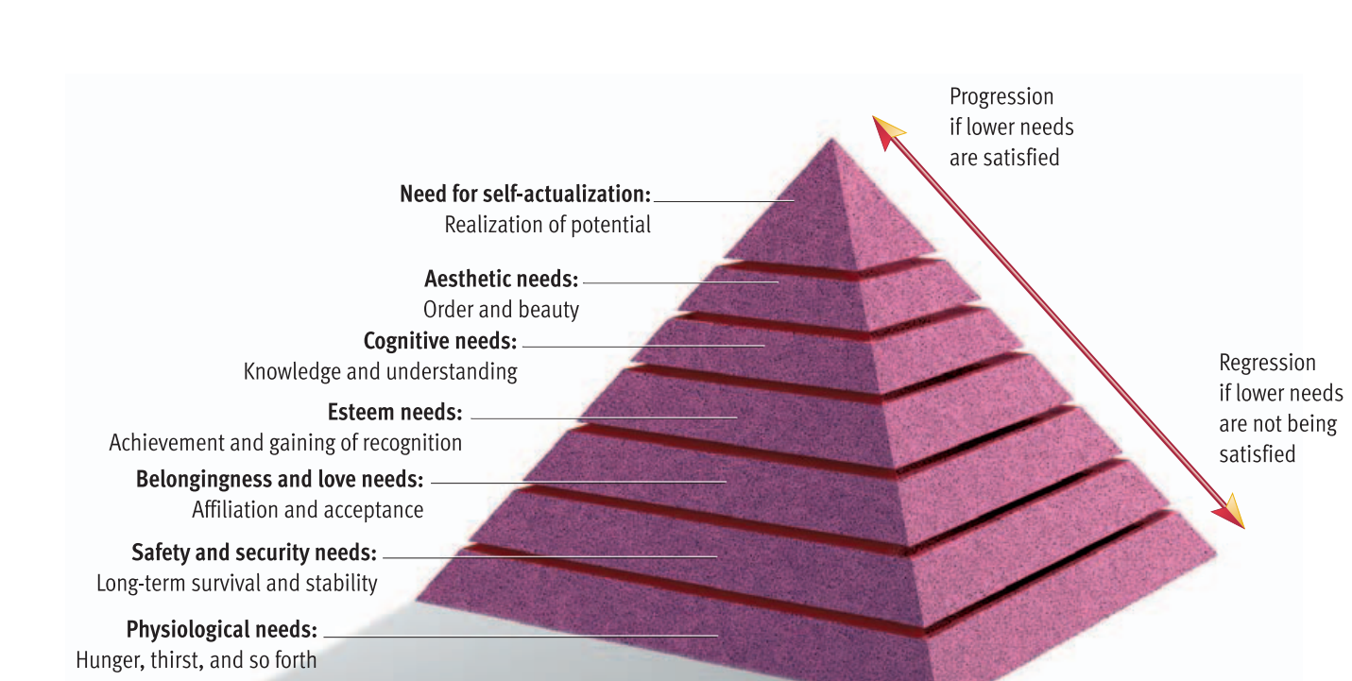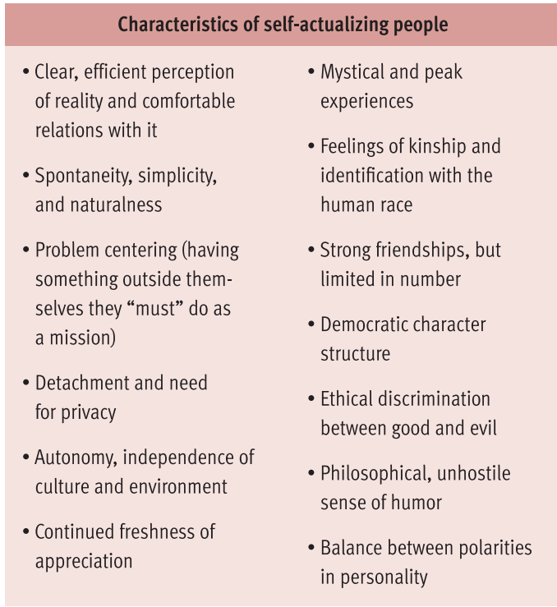

**Hans Eysenck theory**

Jim Lewis and Jim Springer, identical twins separated at birth in 1940, discovered their lives were remarkably similar when reunited in 1979. They shared traits such as driving the same blue Chevrolet, chain-smoking Salems, chewed their fingernails, and owned dogs named Toy and even vacationing at the same beach. Their personalities were also strikingly alike, which highlights findings from a study at the University of Minnesota that explored personality resemblances among identical twins raised apart.

This leads to the question of whether personality is largely inherited. Hans Eysenck, a prominent psychologist, proposed that personality consists of a hierarchy of traits derived from three higher-order traits: extraversion, neuroticism, and psychoticism. Eysenck emphasized that genetics play a significant role in personality development. He theorized that individual differences in physiological functioning influence a person's ability to be conditioned, impacting the personality traits they develop. Specifically, he explored the distinctions between extraversion and introversion, proposing that introverts generally experience higher levels of physiological arousal, which makes them more susceptible to conditioning. Eg, introverts can get hurt more by other’s words directed to that person even if they weren’t and there chances of going to that gathering will reduce.

**Evolutionary theory- David Buss**

Those who could accurately discern traits in others likely had a reproductive advantage.

Building on this, Daniel Nettle posits that these traits themselves evolved because they were beneficial in ancestral environments. For example, extraversion may have increased mating success, neuroticism could have heightened competitiveness and danger avoidance, and agreeableness might have facilitated coalition-building. Nettle also emphasizes the importance of considering the trade-offs of these traits, acknowledging that while they have adaptive benefits, they can also come with potential downsides (e.g., risky behavior associated with high extraversion). Overall, evolutionary perspectives on personality highlight how these traits may have evolved to enhance survival and reproductive success.